Sheet 2 Assignment 5
Team 11

Modified Files:

Kaggle Notebook contains all modifications: https://www.kaggle.com/code/greaat/training-eval-seqtrack

File names:
SeqTrack/experiments/seqtrack/seqtrack_b256.yaml
SeqTrack/lib/config/seqtrack/config.py
SeqTrack/lib/train/data_specs/lasot_train_split.txt
SeqTrack/lib/test/evaluation/lasotdataset.py

Running:

Training:
This command runs in distributed training (Utilizing 2xT4 GPUs)

python -m torch.distributed.launch --nproc_per_node 2 lib/train/run_training.py --script seqtrack --config seqtrack_b256 --save_dir .

Testing:
Run this command to start testing, then second one to analyze results.

python tracking/test.py seqtrack seqtrack_b256 --dataset lasot --threads 4
python tracking/analysis_results.py

………………………………………………………………………………………………………………..

Members Output:

Each member was assigned the following:

Member 1 -> Mohamed Abdulazeem
Member 2 -> Mazen Hesham
Member 3 -> Mohamed Akram
Member 4 -> Mario Mamdouh
---
Member 5 -> Mohamed Rezk
Member 6 -> Mohaemd Tarek
Member 7 -> Mohamed Sherif
Member 8 -> Mustafa Gomaa
Member 9 -> Mohamed Gamal
Member 10 -> Mohamed Essam

Each member number corresponds to subset of the classes (5 classes) according to the sheet, with the first four members assigned two groups of 5.

Mohamed Abdulazeeem - 20220414:

Group1: [airplane, basketball, bear, bicycle, bird]

Tables:

Table 1: Inference rate results

Sequence | FPS
airplane-18 (ID=0) | 46.69
airplane-17 (ID=1) | 9.48
airplane-20 (ID=2) | 39.80
airplane-19 (ID=3) | 35.94
basketball-20 (ID=4) | 33.37
basketball-19 (ID=5) | 17.86
basketball-18 (ID=6) | 29.57
basketball-17 (ID=7) | 3.75
bear-19 (ID=8) | 21.80
bear-18 (ID=9) | 41.78
bear-17 (ID=10) | 26.76
bear-20 (ID=11) | 19.93
bicycle-20 (ID=12) | 14.56
bicycle-18 (ID=13) | 17.51
bicycle-19 (ID=14) | 33.89
bicycle-17 (ID=15) | 39.50
bird-20 (ID=16) | 30.74
bird-18 (ID=17) | 23.93
bird-19 (ID=18) | 11.45
bird-17 (ID=19) | 32.35

Table 2: Evaluation results

AUC | OP50 | OP75 | Precision | NormPrec
26.48 | 14.76 | 0.83 | 13.36 | 9.72

Graphs:

The provided plots (Loss, IoU, Success, Precision) visualize final evaluation results after training, showing IoU- and distance-based performance across varying thresholds.
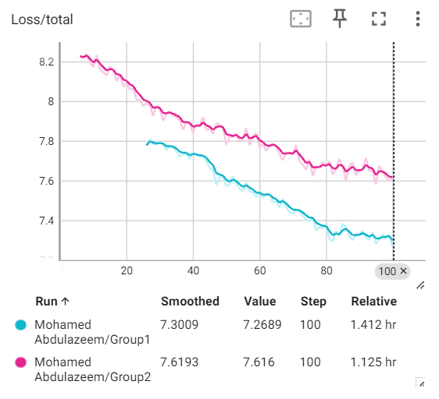
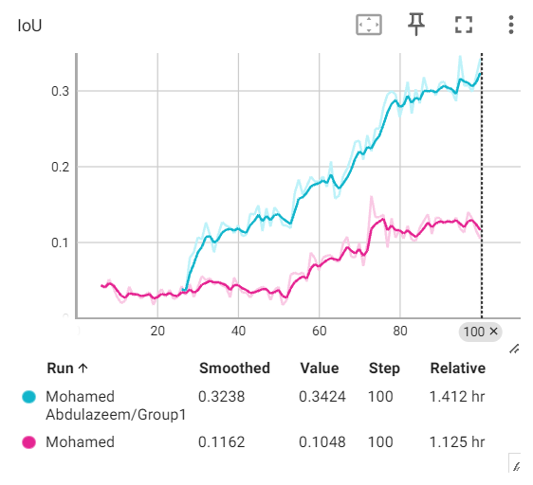
Cyan is Group1
Pink is Group2
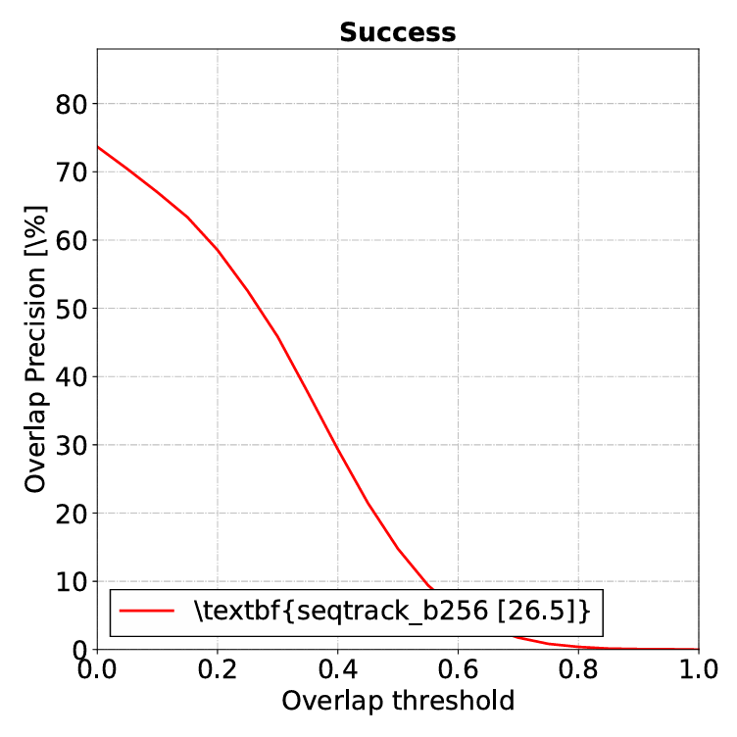

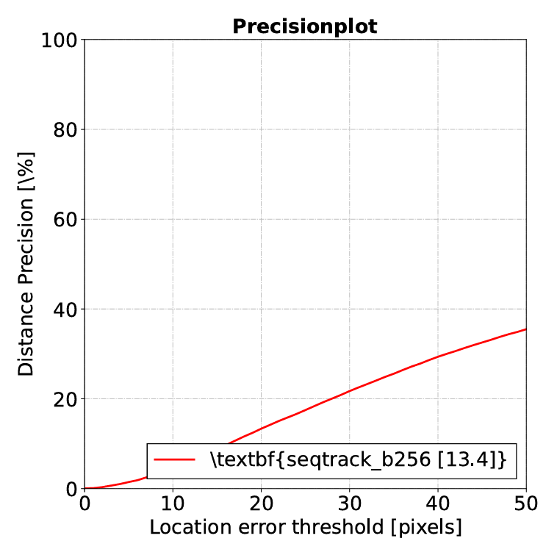

Group2: [boat, book, bottle, bus, car]

Tables:

Table 1: Inference rate results

Sequence | FPS
boat-19 (ID=0) | 1.69
boat-17 (ID=1) | 2.23
boat-18 (ID=2) | 3.84
boat-20 (ID=3) | 1.53
book-17 (ID=4) | 0.62
book-20 (ID=5) | 0.55
book-19 (ID=6) | 1.24
book-18 (ID=7) | 1.75
bottle-19 (ID=8) | 3.54
bottle-20 (ID=9) | 22.37
bottle-18 (ID=10) | 0.14
bottle-17 (ID=11) | 5.44
bus-19 (ID=12) | 0.09
bus-18 (ID=13) | 0.29
bus-17 (ID=14) | 20.14
bus-20 (ID=15) | 2.91
car-20 (ID=16) | 1.42
car-17 (ID=17) | 13.84
car-19 (ID=18) | 1.41
car-18 (ID=19) | 0.42

Table 2: Evaluation results

AUC | OP50 | OP75 | Precision | NormPrec
4.61 | 0.14 | 0.05 | 7.74 | 8.96

Graphs:

The provided plots (Loss, IoU, Success, Precision) visualize final evaluation results after training, showing IoU- and distance-based performance across varying thresholds.



Cyan is Group1
Pink is Group2
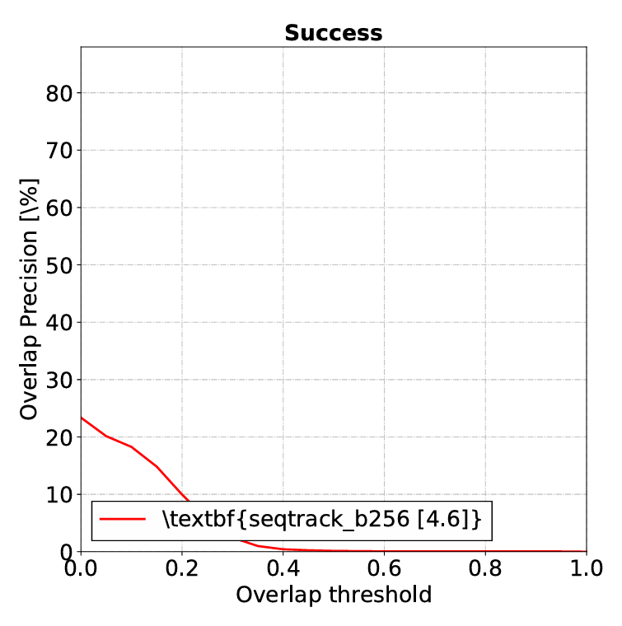

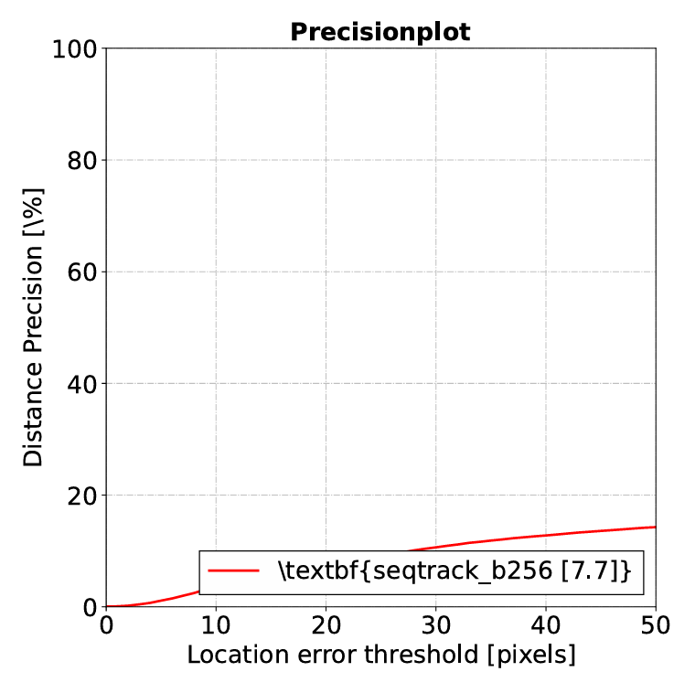

………………………………………………………………………………………………………………..

Mario Mamdouh - 20220358

Group1: [guitar, hat, hand, helmet, hippo]

Tables:

Table 1: Inference rate results

Sequence | FPS
guitar-20 (ID=0) | 44.44
guitar-18 (ID=1) | 43.52
guitar-19 (ID=2) | 11.43
guitar-17 (ID=3) | 43.55
hat-18 (ID=4) | 28.81
hat-20 (ID=5) | 17.66
hat-19 (ID=6) | 0.47
hat-17 (ID=7) | 36.05
hand-19 (ID=8) | 12.24
hand-17 (ID=9) | 22.73
hand-20 (ID=10) | 25.13
hand-18 (ID=11) | 23.56
helmet-20 (ID=12) | 19.35
helmet-17 (ID=13) | 5.17
helmet-18 (ID=14) | 18.65
helmet-19 (ID=15) | 18.85
hippo-20 (ID=16) | 41.97
hippo-17 (ID=17) | 19.47
hippo-19 (ID=18) | 9.64
hippo-18 (ID=19) | 25.62

Table 2: Evaluation results

AUC | OP50 | OP75 | Precision | NormPrec
23.55 | 13.16 | 1.38 | 19.03 | 10.21

Graphs:

The provided plots (Loss, IoU, Success, Precision) visualize final evaluation results after training, showing IoU- and distance-based performance across varying thresholds.

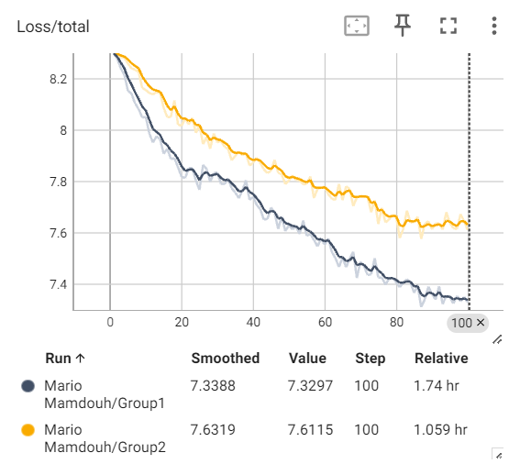
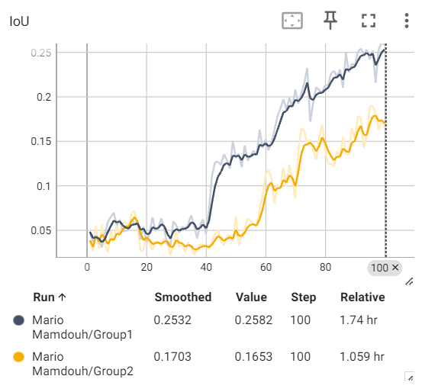
Black is Group1
Yellow is Group2
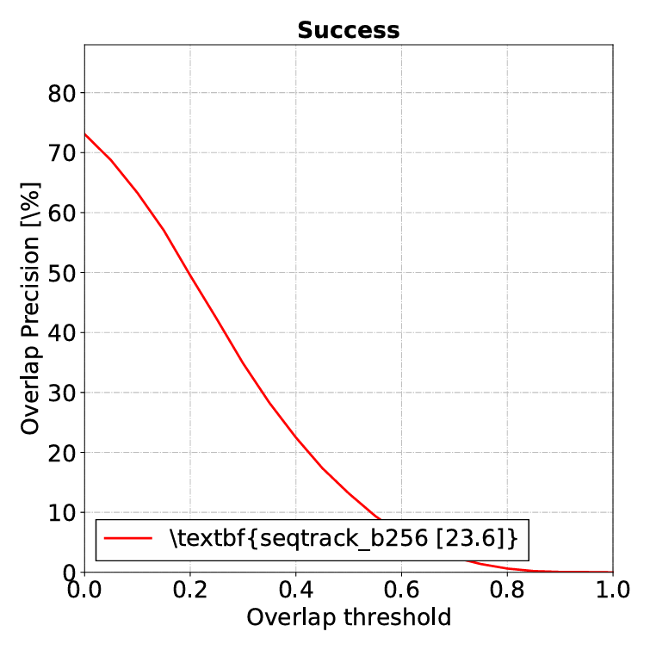

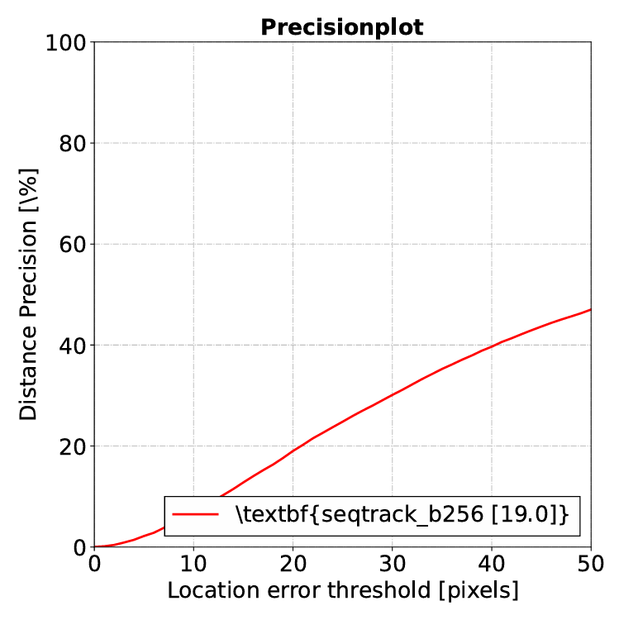

Group2: [horse, kite, kangaroo, leopard, licenseplate]

Tables:

Table 1: Inference rate results

Sequence | FPS
horse-20 (ID=0) | 0.05
horse-18 (ID=1) | 0.09
horse-19 (ID=2) | 0.32
horse-17 (ID=3) | 0.07
kite-18 (ID=4) | 0.18
kite-20 (ID=5) | 0.40
kite-19 (ID=6) | 0.34
kite-17 (ID=7) | 0.20
kangaroo-19 (ID=8) | 0.20
kangaroo-17 (ID=9) | 0.13
kangaroo-20 (ID=10) | 0.08
kangaroo-18 (ID=11) | 0.09
leopard-20 (ID=12) | 0.10
leopard-17 (ID=13) | 0.12
leopard-18 (ID=14) | 0.20
leopard-19 (ID=15) | 0.18
licenseplate-20 (ID=16) | 0.36
licenseplate-17 (ID=17) | 2.91
licenseplate-19 (ID=18) | 32.17
licenseplate-18 (ID=19) | 28.75

Table 2: Evaluation results

AUC | OP50 | OP75 | Precision | NormPrec
3.95 | 0.69 | 0.04 | 10.89 | 2.94

Graphs:

The provided plots (Loss, IoU, Success, Precision) visualize final evaluation results after training, showing IoU- and distance-based performance across varying thresholds.



Black is Group1
Yellow is Group2

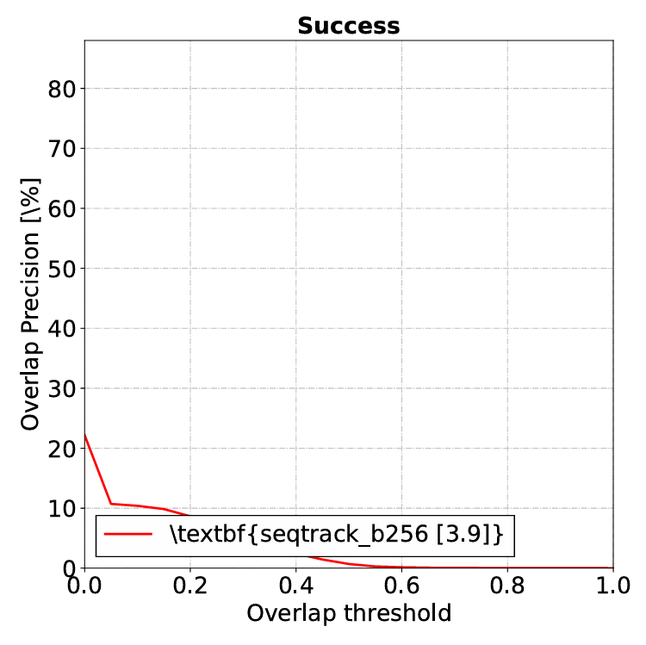

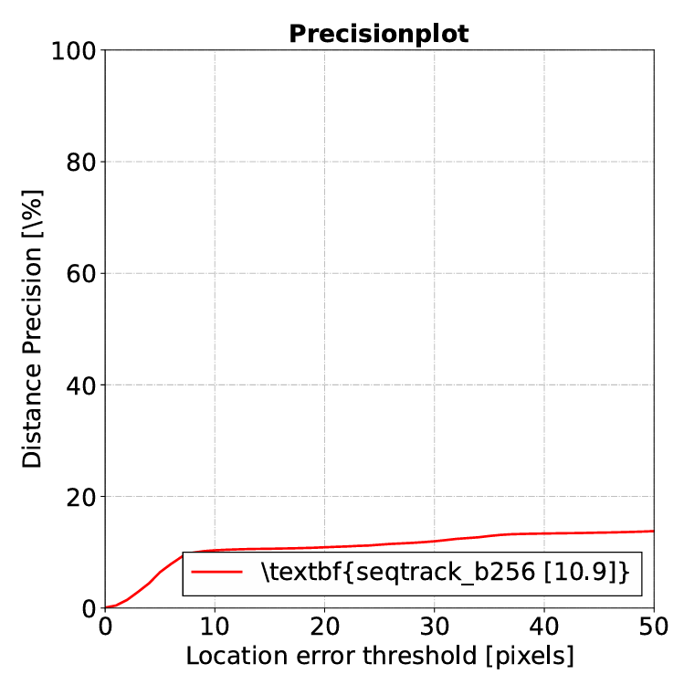

………………………………………………………………………………………………………………..

Mohamed Akram - 20220383

Group1: [frog, fox, flag, elephant, electricfan]

Tables:

Table 1: Inference rate results

Sequence | FPS
frog-20 (ID=0) | 5.72
frog-18 (ID=1) | 11.93
frog-19 (ID=2) | 49.32
frog-17 (ID=3) | 12.02
fox-18 (ID=4) | 57.42
fox-20 (ID=5) | 3.27
fox-19 (ID=6) | 38.78
fox-17 (ID=7) | 19.02
flag-19 (ID=8) | 6.55
flag-17 (ID=9) | 26.50
flag-20 (ID=10) | 50.98
flag-18 (ID=11) | 44.15
elephant-20 (ID=12) | 16.25
elephant-17 (ID=13) | 18.64
elephant-18 (ID=14) | 45.13
elephant-19 (ID=15) | 18.65
electricfan-20 (ID=16) | 41.35
electricfan-17 (ID=17) | 47.35
electricfan-19 (ID=18) | 48.61
electricfan-18 (ID=19) | 8.10

Table 2: Evaluation results

AUC | OP50 | OP75 | Precision | NormPrec
28.03 | 24.63 | 2.28 | 14.92 | 23.47

Graphs:

The provided plots (Success, Precision) visualize final evaluation results after training, showing IoU- and distance-based performance across varying thresholds.
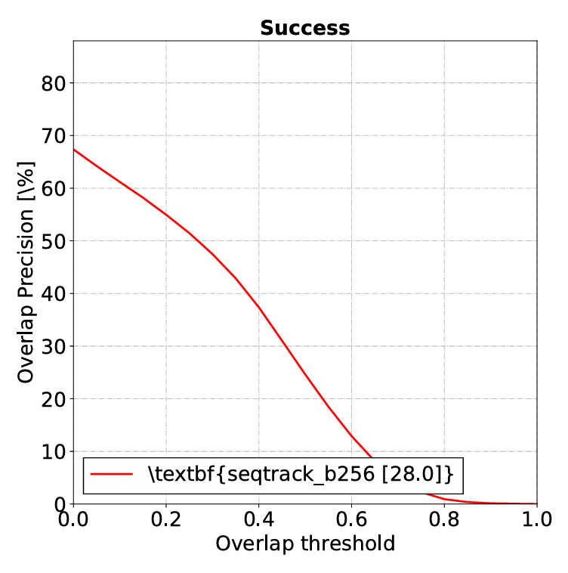

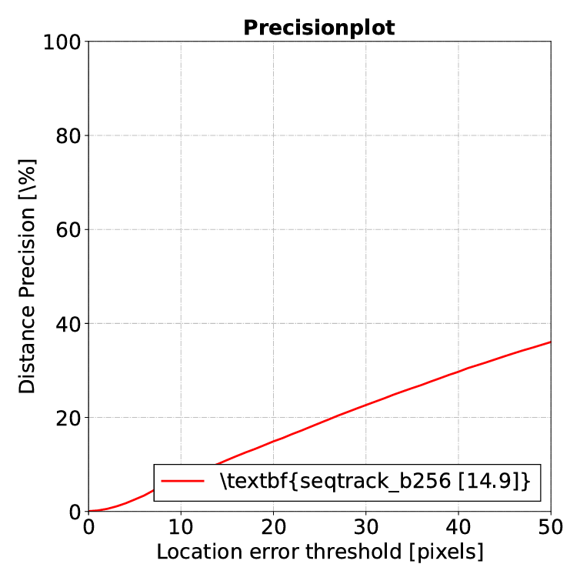

Group2: [gametarget, gecko, giraffe, goldfish, gorilla]

Tables:

Table 1: Inference rate results

Sequence | FPS
gametarget-20 (ID=0) | 0.06
gametarget-18 (ID=1) | 0.20
gametarget-19 (ID=2) | 0.13
gametarget-17 (ID=3) | 0.13
gecko-18 (ID=4) | 0.21
gecko-20 (ID=5) | 0.18
gecko-19 (ID=6) | 0.39
gecko-17 (ID=7) | 0.18
giraffe-19 (ID=8) | 0.32
giraffe-17 (ID=9) | 0.41
giraffe-20 (ID=10) | 0.26
giraffe-18 (ID=11) | 0.22
goldfish-20 (ID=12) | 0.13
goldfish-17 (ID=13) | 0.12
goldfish-18 (ID=14) | 0.13
goldfish-19 (ID=15) | 0.25
gorilla-20 (ID=16) | 0.09
gorilla-17 (ID=17) | 0.16
gorilla-19 (ID=18) | 0.45
gorilla-18 (ID=19) | 0.14

Table 2: Evaluation results

AUC | OP50 | OP75 | Precision | NormPrec
0.29 | 0.11 | 0.05 | 0.33 | 0.46

Graphs:

The provided plots (Loss, IoU, Success, Precision) visualize final evaluation results after training, showing IoU- and distance-based performance across varying thresholds.

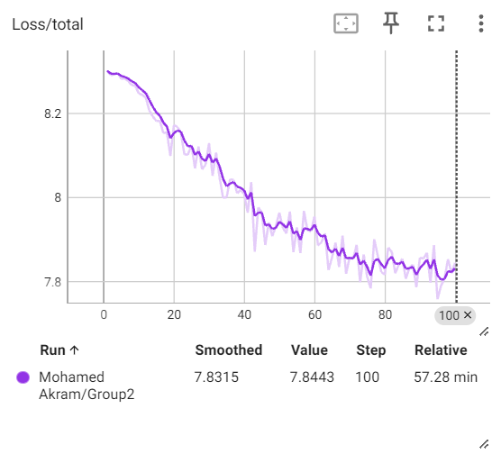

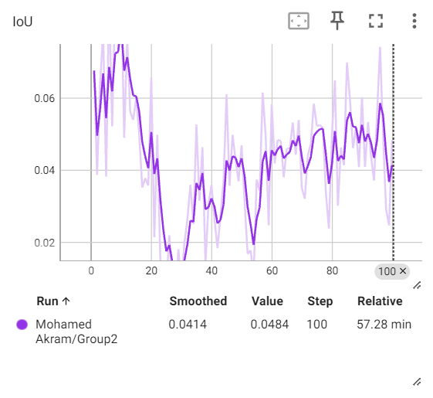




………………………………………………………………………………………………………………..

Mazen Hesham - 20220366

Group1: [cat, chameleon, cattle, coin, crab]

Tables:

Table 1: Inference rate results

Sequence | FPS
cat-18 (ID=0) | 0.16
cat-19 (ID=1) | 0.08
cat-17 (ID=2) | 0.04
chameleon-18 (ID=3) | 0.08
chameleon-20 (ID=4) | 0.09
chameleon-19 (ID=5) | 0.13
chameleon-17 (ID=6) | 0.16
cattle-19 (ID=7) | 0.16
cattle-17 (ID=8) | 0.18
cattle-20 (ID=9) | 0.14
cattle-18 (ID=10) | 0.09
coin-20 (ID=11) | 0.12
coin-17 (ID=12) | 0.18
coin-18 (ID=13) | 0.15
coin-19 (ID=14) | 0.11
crab-20 (ID=15) | 0.07
crab-17 (ID=16) | 0.18
crab-19 (ID=17) | 0.13
crab-18 (ID=18) | 0.12

Table 2: Evaluation results

AUC | OP50 | OP75 | Precision | NormPrec
0.19 | 0.09 | 0.06 | 0.07 | 0.08

Graphs:

The provided plots (Loss, IoU, Success, Precision) visualize final evaluation results after training, showing IoU- and distance-based performance across varying thresholds.

